## 3sMerchant

Scoping start date: 2/13

Implementation Completed Date (Go live date):

MSA Signature Date: 4/23

GTM POC: Rebecca

ERP: QBO

Tax Integration: Other (Anrok)

### 

### Key people at Merchant

### CFO - John Morris - has been at the org for <6 months

* VP Biz Ops / COO - Rickie Goyal - super nice guy. Has been closest to invoicing since John is newer/more strategic anyway
* Edwin - head of the outsourced finance squad. We haven’t met him yet, but he’s closest to their actual mechanics of invoicing and I expect him to play a role in ensuring implementation happens smoothly since he knows all the intricacies of their current process

### Company summary

High ACV cybersecurity software, sold either directly or through channel partners/resellers  
  
AM Notes

None of note. I think they’ll be great to work with.

### Billing model

* Basic subscriptions, varying cadences (annual, quarterly)
* They currently bill ahead of time with Net 180 terms etc so they don’t have to remember to bill for future periods (silly)
* Some complexity when they need to bill the reseller vs. the end user and figure out stuff with POs

### Contract Processing Steps

1. We will be receiving these contracts to contract-ingest. In this email, there will be:
   1. **Table in the email body**
      1. Needed for processing - there is key information included that is not in the PO
      2. Please upload the email body to Tabs, but no BTs will be processed under this doc
   2. **Cyberhaven Quote** (this is the one with the cyberhaven logo at the top)
      1. Needed for processing
      2. Process all BTs under this contract
   3. **Purchase Order**
      1. Not needed for processing EXCEPT for billing/shipping address when a new customer needs to be created (details below)
      2. Please upload to Tabs

***\*\*\*Examples of the PO and Email table are below***

1. Customer assignment/creation rules:
   1. Customer=
      1. If there is a value in the ‘Channel Partner’ row, use this as the customer
         1. This is a reseller agreement
      2. If the ‘Channel partner; row says ‘n/a’, then use the “End User Account’ as the customer
   2. If the customer already exists, link to the existing customer in Tabs
      1. **Customer = Channel Partner**
         1. **End User is NOT the customer**
   3. If the customer does not exist, create a new customer:
      1. Billing address: found on PO
      2. Shipping address: For all reseller agreements, do NOT add a shipping address. This information can be found in the table in the email body
         1. At the top of the table, there are rows for End User and Channel Partner - if there is a separate value in the ‘Channel Partner’ row, you should NOT add the shipping address when adding the customer (example in the image below)
         2. If there is an ‘n/a’ in the ‘Channel Partner’ row, then please add shipping address from the PO when adding the customer (or mark as ‘same a billing address’ if applicable)

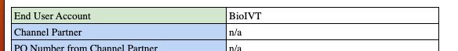

* + 1. Billing contact: found in the table in the body of the email in the ‘Invoice contact’ and ‘Email for Invoice’ rows

1. For processing, start with the Quote document. Then, if necessary, refer to the table in the email body for a few key items:
   1. Item name: name of SKU, usually starts with CYB, from Quote
   2. Description: include full description from the quote
   3. Qty: from QTY column in quote
   4. Amount: Total amount from quote
   5. Integration item: All items on the quote listed as their SKU name, but the integration items in Tabs show the display name. Some match each other, but some are a name vs a code. All mappings of display name to SKU name are listed below in the “Integration Items” section.
   6. Net terms: DO NOT USE QUOTE. Refer to table in email body, there will be a Net Payment Terms row
   7. Start date/service period: Sometimes this is in the quote, if not refer to the table in the email body
   8. PO#:
      1. Refer to table from email
         1. If value in “PO Number from Channel Partner”, use this
         2. If “PO Number from Channel Partner” says n/a, use “PO Number from End User”,

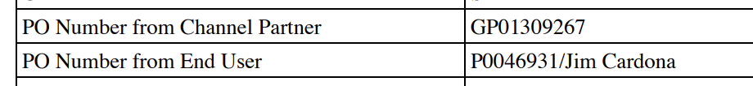

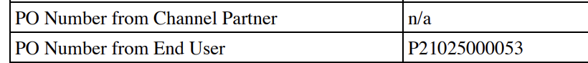

* + 1. After the BTs are processed, enter to PO# from the PO via the Invoice tab from the Additional Actions section. (see image below)

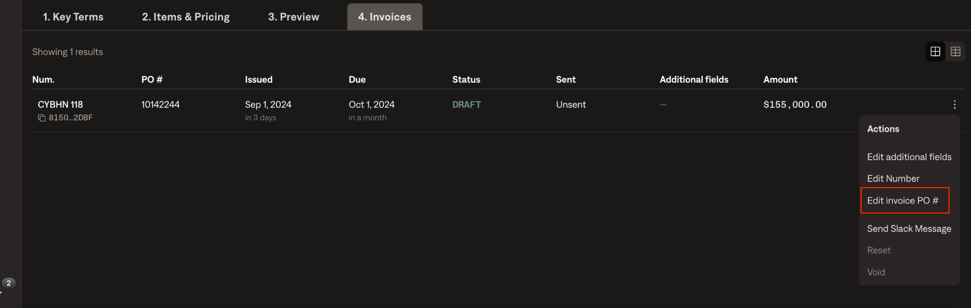

If the quote/purchase order for some reason does not have certain billing terms, [use this document](https://garage.tabsplatform.com/prod/contracts/75210fa2-75a0-4f23-9036-23d2f29aa143/terms/key)

**Email body table example:**

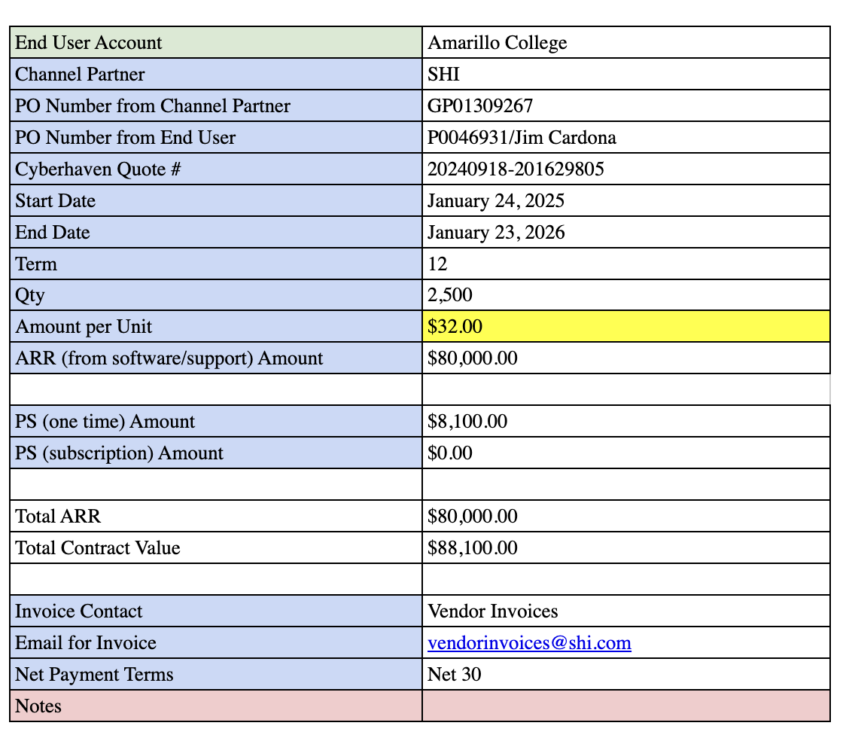

**PO Examples:**

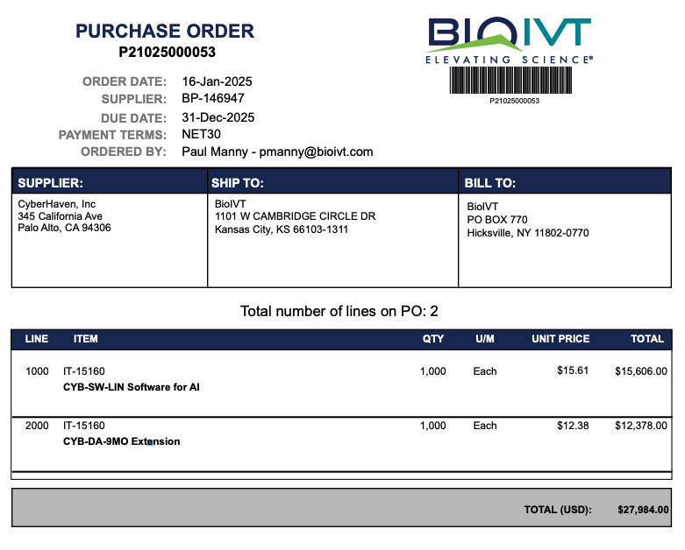

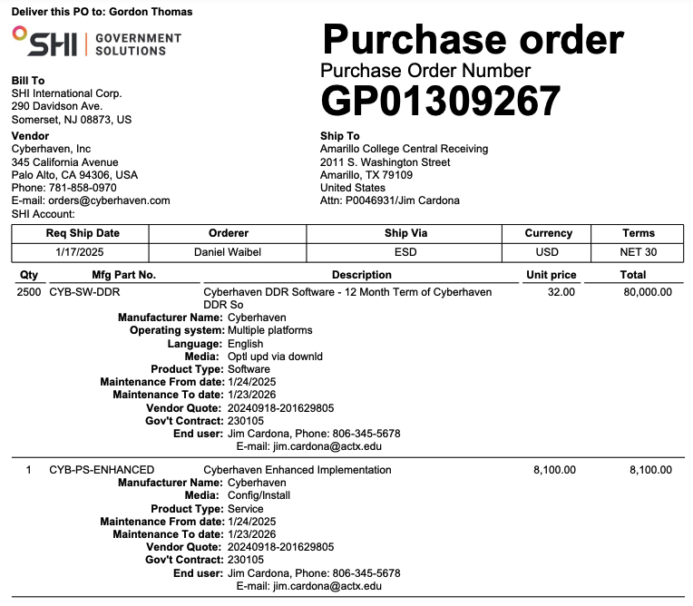

### Integration Items

* This list will be added to, but so far that mappings we have are:
  + CYB-SW-DDR = Cyberhaven License
  + CYB-PS-ADVANCED = CYB-PS-ADVANCED
  + CYB-PS-LAUNCH = Cyberhaven Professional Services
  + CYB-ADV-CONT-INSP = Cyberhaven Advanced Content Inspection

**More mappings are seen in the images below (SKU names are slightly cut off, but hopefully this is enough to decipher)**

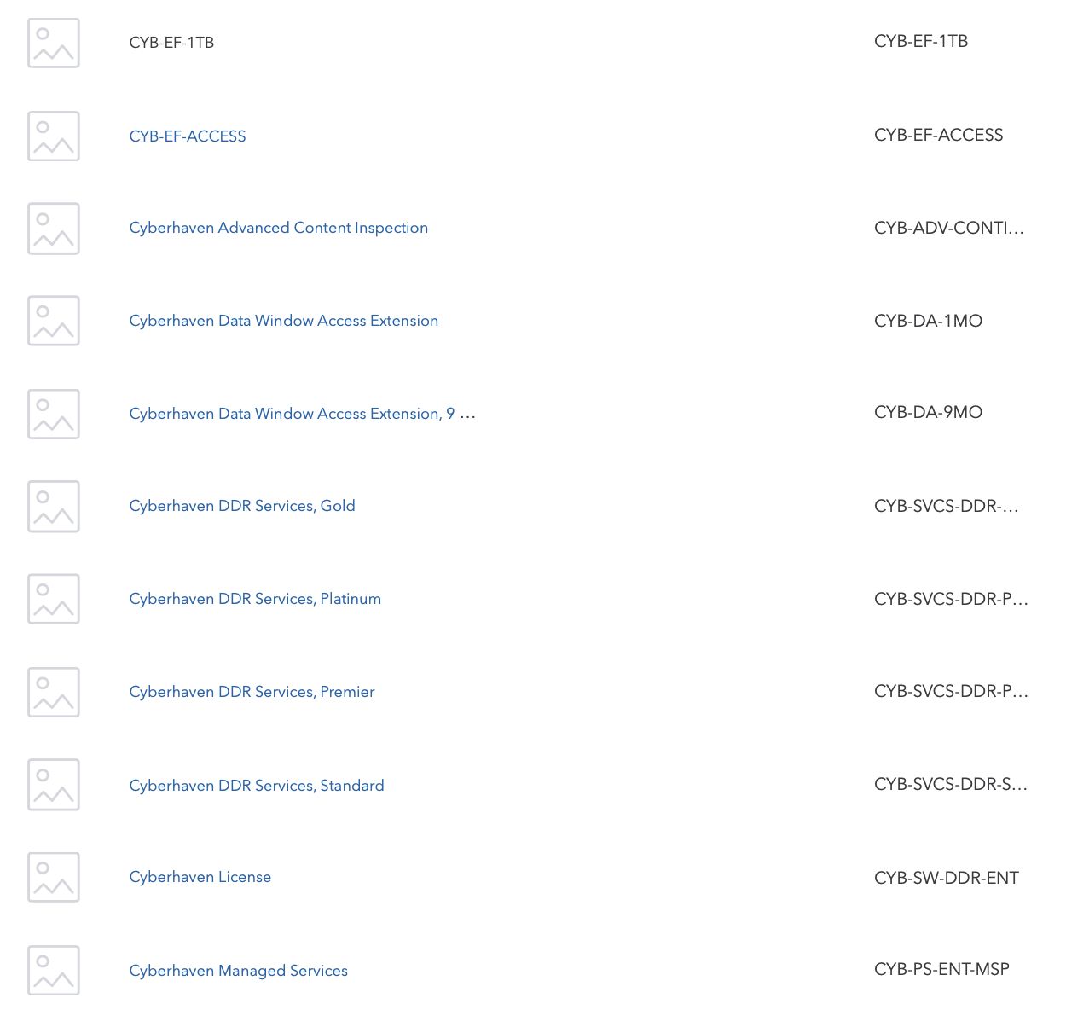

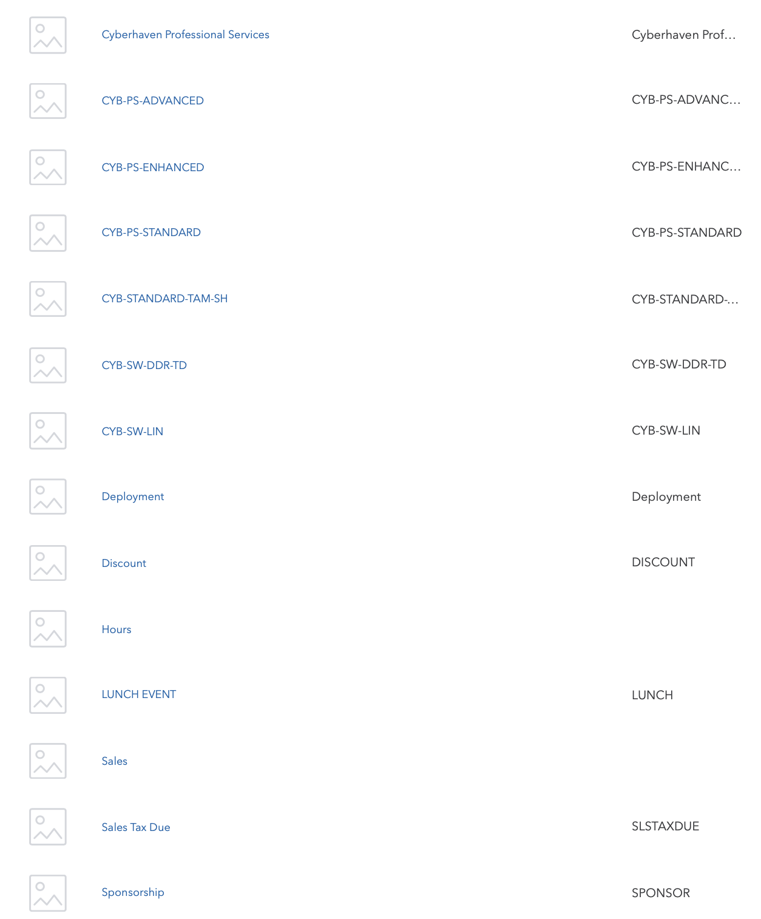

### Events Processing (if necessary)

* N/A

### Customer Information

* Any important information on specifics customers of this merchant
  + Special memo’s certain invoices require
  + Invoice changes due to merchant/customer relationship

### Feature Requests

* FR 1
  + What is it
  + Why it's important
  + Urgency

### Rewatch Calls

* Rewatch by dates